MBARARA UNIVERSITY OF SCIENCE AND TECHNOLOGY

FACULTY OF COMPUTING AND INFORMATICS

Bachelor of Science in Computer Science

. Web Application Development

Course Code: CSC22

Student Name: ASHABA RONAH

Student Number:2100601764

Reg Number:2021/BCS/022/PS

August, 2023

**HOTEL SYSTEM REPORT**

**Introduction**

Acacia hotel website is a digital gateway of luxury and hospitality, the nested at intersection of comfort and elegance. acacia is not just a place to stay, it’s an experience that encapsulates opulence, warmth and impeccable services.

The main aim for designing a website is to help people book or get in contact with the manager to stay in case the are in need of our services.

What motivated me to clone acacia hotel website by the desire to extend the hospitality beyond the walls of the establishment, our website serves as a window into the soul of acacia

**The difference between cloned website and actual website**

For the cloned website the booking part where the client is supposed to do the booking part because it shows you the exact room to room and the number required for each room. Whereas for the actual website booking is done using the website where you contact them by submitting an email without knowing the room you have booked.

On the sign in for the actual website password is not required whereas for the cloned website the password is required.

The out standing thing with my website is that even if you’re signing in you need to know your password for you to receive the services provided at the hotel and this mainly ensures the security of our clients credentials as some one can easily sign up using your email if the password is not required

**The cloned website**

I cloned the acacia website/ application using Httracker to copy the source code from the original website and used edited it to my own website using the Python Django framework version 4.1, SQLite, Gmail, html5, CSS.

The Django framework was used to create and manage the application’s operations and navigation throughout the site, SQLite as a database server (store and retrieve records), Bootstrap for responsiveness of the web pages and different attributes, Gmail for email services, html for creating web pages, CSS for styling and designing web pages. This web system is made up of a different categories of web pages which include home page, Accommodations page, meeting and events of page, restaurant page, our gallery page, sign in page and contact us page. The home page contains different hyperlinks in the navigation bar which when clicked directs the user to the corresponding log in page. The home page is shown in the figure below.

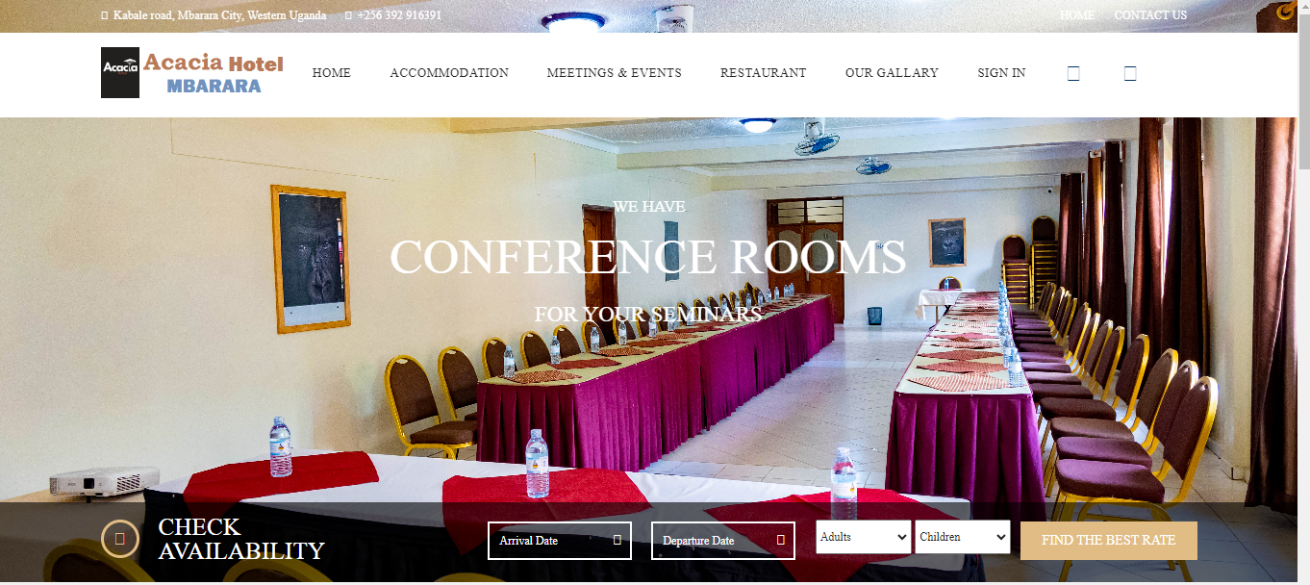

From the home page, different pages were designed to enable different users to identify their corresponding dashboards. A user has sign up at any page of the site, he or she has to user his or her email as the username and create password of his or her choice. Below is the signup page and sign in page.

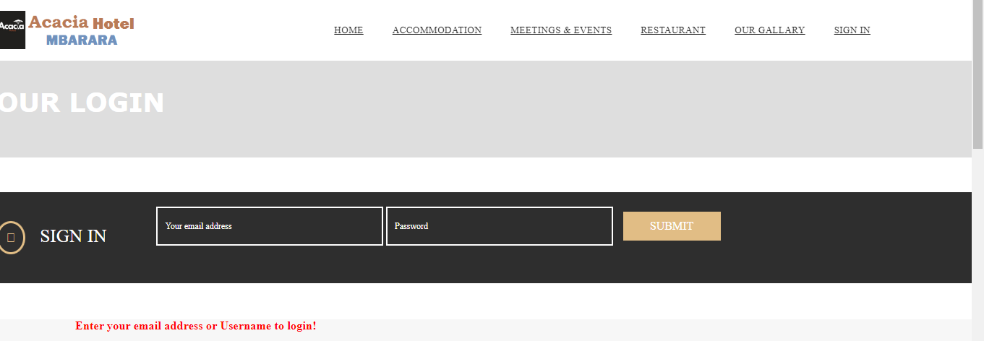

On the sign in page, the user types in his or her email address (used as username) and password. Once the credentials submitted don’t match, an error message is displayed on top of the page indicating that username and password did not match with what was registered in the database while signing up.

Django models have been used to create various tables in the database which are used to store information from the web pages. Below is an example of a model that stores customer details and their username in a database and the models created include the signup model and contact us model as below

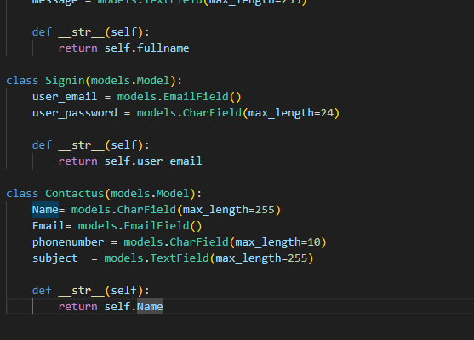

I used the Django views to render and redirect to different web pages on request by the user. More so, they have been used with the help of “POST” method to transfer data from a webpage (in put fields) to the models for storage and retrieving using query sets. Below is a sample of a view used to post data on the contact us page and sign in page.

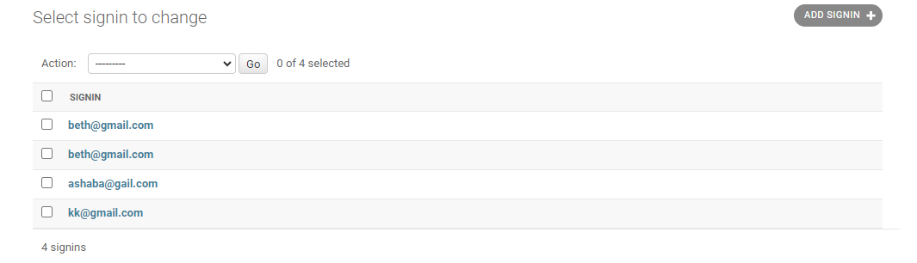

As this website is for check out the services offered at acacia hotel. In case someone wants to book a room, he had to first check the availability in the hotel. In case of free space then he can go to the contact us page to do the booking of the room. Since the person is already registered in the website, he will receive a notification that shows that the place has been booked. The customer can check out the price required for each on the website by clicking on the button of check availability because the service is always attached with the price.

**Inconclusion**

In this word where technology bridges distance and enhances interactions. my website is a testament to our efforts to connect with you before you even arrive at the hotel. As you explore the captivating images, read about our lavish amenities and plan your dream to stay.